As some people who know be may be aware, I was born into showing. My granddad (John Dixon) owns a number of Jacob sheep. From the age of 3 my older sister (Abi) had started showing. When I was born I would be wrapped up and taken along to watch and cheer her on. When I was old enough to walk I’d climb into the pen with Abi and help her get the sheep ready, but for me this was not enough I wanted to get in the ring and have a go myself and that’s how my showing life began. 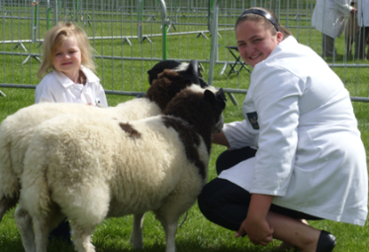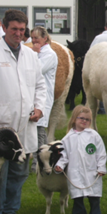
Abi and Caitlin showing the sheep
Caitlin learning from the grandpa john

As I grew up and got more experience I went on to win more and more rosettes and then went on to win cups, trophies and champion rosettes but I have also had my fair share of losing.
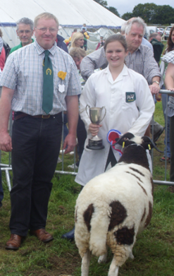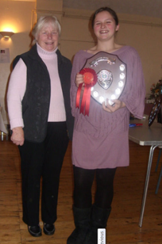
Some of the trophies I have won

I compete in many shows including Blaston, East of England, Leicester, Morgreen, Rutland, Autumn exhibition, The Winter Stock Show, Ashby and others. It was at one of these shows, the Autumn exhibition that we got the news that my little sister Caitlin had been born and just as I had been she was brought in to sheep showing.
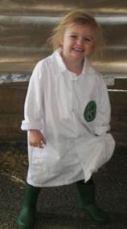
Already in the white coat at three

At the end of last year I went on to qualify for the RBST young shepherd of the year competition which I was very pleased about. My year ended on a high point when at my last show, the winter stock show and sale, me and my little sister entered the young handler competition and many more classes and we both went on to win our classes which meant that we had to go head to head as well as against the winner of the 17-21yrs class for the champion young handler. My little sister beat me taking the title champion young handler and leaving me to take the reserve champion (I’ve taught her well.) Let’s hope that I can do better at the RBST young shepherd competition.
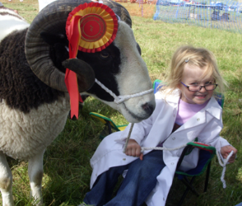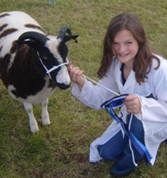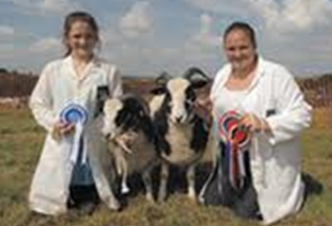
Some of the other shows we have done well at

Report from BETH FINCHAM FEBRUARY 2013

